**Name: Qianzi Xu(Rachel)**

**CMSC110 Introduction to Computing  
Assignment#1 (Due on Thursday, September 25, 2014)**

**Description and Thoughts**

Figure 1: The Uncommon Clock (Rachel Xu)

A clock (with only the second hand) that can be controlled via keyboard (moving the hand, changing the color, resetting etc).

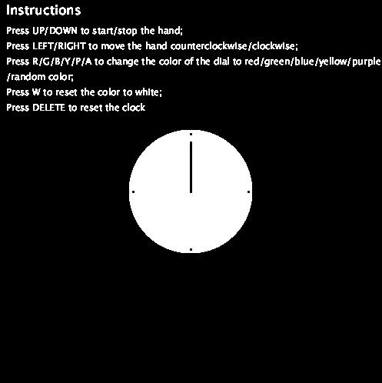

**[Insert your Image here]**

Descriptions of how the clock functions are above the clock itself.

This clock actually looks very simple and I didn’t expect to spend so much time on it. While I was trying to add new functions to the clock, I encountered a lot of trouble. For example, the change of color: when I pressed the key, the color did change, but only stayed as long as the key was pressed; moreover, the color of the text changes with the color of the dial, which is not what I intended. I guess these problems arose from a lack of understanding of the scope of variables but haven’t figured out how to deal with them, and this situation prevented me from adding more interesting features. Despite these obstacles, the process of creating this clock was fun: I tried the rotate () function and figured out how to control the movement of the second hand by altering the size of each step; I also learned to design interactivity using keyboard, which allows more flexibility than the mouse. I realize that my clock has not so much aesthetic value as practical value (and still not useful enough to be qualified as a real clock), but it is easier to adjust and has some features that a common clock doesn’t have.